**Software Requirements**

**Specification**

**for**

**<OLA AND UBER>**

**Version 1.0 approved**

**Prepared by**

**<Emani.Venkata Sailakshmi Jahnavi-21MIS1151>**

**<D.Rushma-21MIS1143>**

**<B.Pujitha-21MIS1090>**

**VIT Chennai**

**27-02-2023**

Copyright © 1999 by Karl E. Wiegers. Permission is granted to use, modify, and distribute this document.

**Software Requirements Specification for <**OLA AND UBER**> Page ii**

# Table of Contents

Table of Contents 2

Revision History 2

1. Introduction 1

1.1 Purpose 1

1.2 Document Conventions 1

1.3 Intended Audience and Reading Suggestions 1

1.4 Product Scope 1

1.5 References 1

2. Overall Description 1

2.1 Product Perspective 2

2.2 Product Functions 2

2.3 User Classes and Characteristics 3

2.4 Operating Environment 3

2.5 Design and Implementation Constraints 3

2.6 User Documentation 4

2.7 Assumptions and Dependencies 4

3. External Interface Requirements 4

3.1 User Interfaces 4

3.2 Hardware Interfaces 4

3.3 Software Interfaces 7

3.4 Communications Interfaces 7

4. System Features 7

4.1 System Feature 1 7

4.2 System Feature 2 (and so on) **Error! Bookmark not defined.**

5. Other Nonfunctional Requirements 9

5.1 Performance Requirements 9

5.2 Safety Requirements 9

5.3 Security Requirements 9

5.4 Software Quality Attributes 10

5.5 Business Rules 10

6. Other Requirements 10

Appendix A: Glossary Error! Bookmark not defined.

Appendix B: Analysis Models Error! Bookmark not defined.

Appendix C: To Be Determined List Error! Bookmark not defined.

# Revision History

|  |  |  |  |
| --- | --- | --- | --- |
| **Name** | **Date** | **Reason For Changes** | **Version** |
|  |  |  |  |
|  |  |  |  |

# Introduction

In this era transport became an important part of our life. It is important to reach the location on time, so online booking apps like Ola and Uber provides facilities of transport to individual or group of people reducing time and efforts to customers as well as company. These apps can track the location and estimate the arrival.

## 1.1 Purpose

The purpose of this SRS document is to specify software requirements of Ola and Uber online travel booking apps.These travelling apps are intended to make the journey as smooth as it is. The technical and design aspects of these apps are going to be discussed in the future of this document.

## 1.2 Document Conventions

## Title at the head of a section is in bold-Times New Roman

## Information in the document is in Arial format.

## 1.3 Intended Audience and Reading Suggestions

## To some extent this document is specified only to the development, designing and testing team. Users can't be able to understand the UML diagrams that are included in this document.

* To get an overall idea and scope of this project, the sequence of reading should be as the document flow contains. Otherwise, if the user is not interested in the technical and designing aspects, it is better to go with the abstract reading of the document.

## Product Scope

The aim of the project is going to carry out as a research analysis that includes comparing the requirements of the ridesharing apps OLA and UBER and to know the lacking functional and non-functional requirements of the apps. The main goal of this project is to know the process carried out in organization and realize the vision of the additional functional and non-functional, which helps in showing the available vehicles to book and making a secure journey by the users.

## 1.5 References

* <https://www.studocu.com/en-us/document/california-baptist-university/federal-income-tax-accounting/srs-online-taxi-booking/17826205>
* <https://rupkatha.com/V11/n3/v11n310.pdf>

# 2. Overall Description

## 2.1 Product Perspective

Ola and Uber provide bike, car and courier services for customers. This company uses online system for booking, register and to keep record of all the booking activities and customer information. The detailed existing system functions are listed as follows:

While booking a car or bike the user provide their location and see the cost and select them. They provide their personal information and have access to check payment status and to track the location.

These app contains history of how many times we have booked the vehicle or made courier.

## 2.2 Product Functions

Sign Up: Users need to sign up to use the web site. The users should

have a username and password. After filling their name, surname, email, age, job, phone and gender information, they register the system.

Sign In: If a user is signed up, s/he can sign in the system by filling

username and password boxes.

Sign Out: A user may need to sign out the system. S/he can do it by

clicking the sign out button which is placed in every page.

Add Transportation Route: Users may add transportations by

specifying a route, time/time period and number of empty seats. The

user can select the route by two different way. The first way is entering

start and end locations. Thus, the route is drawn on the map. The other

way is selecting start and end locations on the map. Also, he/she can

select at most 8 waypoints.

Delete Transportation Route: A user may delete his/her

transportation route. After deleting route, other passengers in that

transportation will be informed by the system.

Request Transportation Route: A user may use a transportation by

sending transportation request to the driver of the transportation.

Search Transportation Route: A user can search for transportations

that the user can see suitable routes to his/her route by specifying time

and route.

## 2.3 User Classes and Characteristics

Customer:

* User can login to the system.
* Visit the mobile app.
* Confirm the pickup.
* Cancel the pickup.

Maintenance manager:

* It checks for the maintenance.
* Give to the maintenance.
* Give information to the admin.
* Maintain the database

Admin:

* Admin can login to the system.
* Verify the information database.
* Generate price strategy
* Handle the payment system.
* Finalize the order.
* Cancel the account.

## 2.4 Operating Environment

Ola and Uber Website shall be compatible with standard web browsers on Windows, Mac, and Web-enabled smart phone platforms. (Supported browsers are Internet Explorer 5, 6, 7, and 8; Firefox 2 and 3; Opera 10 and 11; Google Chrome 10 and later).

Ola and Uber are also used as Phone Application shall be compatible with Android and IOS platforms. (Supported Android 5.0 and later; IOS 8.0 and later.)

**2.5 Design and Implementation Constraints**

**OLA:**

Utilizing programming languages like Java, Python, and

open-source RDBMS and NoSQL databases. Utilizing Hadoop modules such as YARN & MapReduce, and related Apache projects such as Hive, HBase.

**UBER:**

Engineers here primarily write in Python, Node.js, Go, and Java. They started with two main languages Node.js for the Marketplace team, and Python for everyone else.

## 2.6 User Documentation

Online documentation facility is available for the clients to assess them for the

easy use.

* Online documentation facility is available for the clients to assess them for the easy use.
* A specific document should be prepared for the maintenance of the system and should say the system in easiest way

## 2.7 Assumptions and Dependencies

* Vehicles are already purchased and available for use.
* Roles and responsibilities are already established.
* Administrator is already created

# 3. External Interface Requirements

## 3.1 User Interfaces

## OLA:

## The first screen the user looks at while launching the app:

The bottom deck after logging to the home screen shows up to select the destination ride for the user:

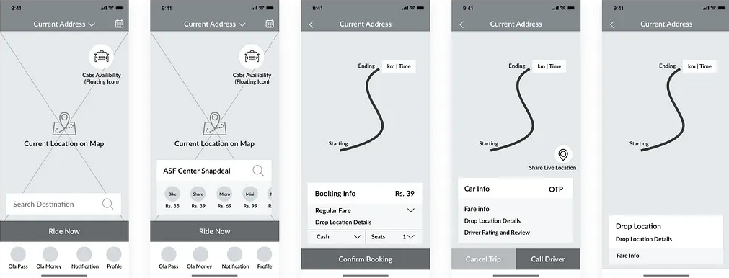

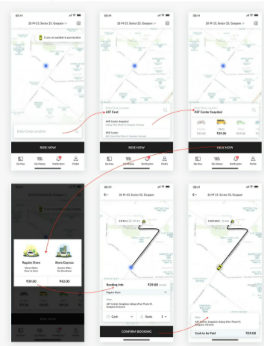

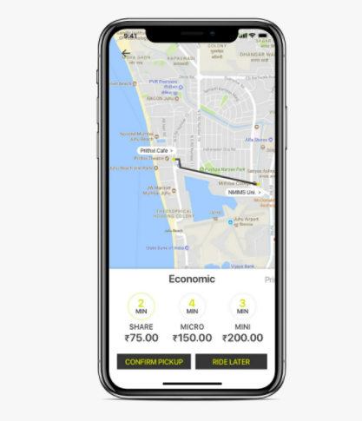

**UBER:**

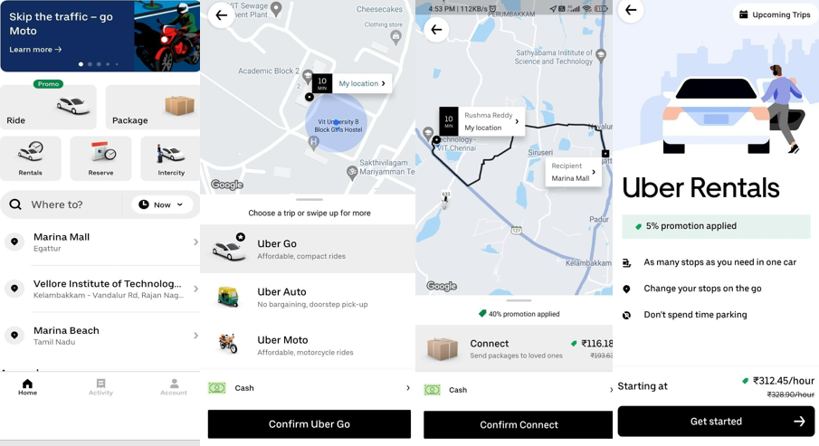

## 3.2 Hardware Interfaces

Ola and Uber use standard hardware and data communication. This is mainly used for car or bike or courier transport booking. GPS system tracks the current location and provides nearby vehicle at any time. Therefore, the taxi client’s applications must be installed on an android device with a built-in-GPS. GPS used to calculate the speed and time of the vehicle to arrive or to reach.

## 3.3 Software Interfaces

Ola uses 49 technology products and services including HTML5, jQuery, and Google Analytics, according to G2 Stack.

Ola is actively using 70 technologies for its website, according to BuiltWith. These include SPF, LetsEncrypt, and Google Font API.

Uber uses 91 technology products and services including HTML5, jQuery, and Google Analytics, according to G2 Stack.

Uber is actively using 84 technologies for its website, according to BuiltWith. These include LetsEncrypt, WordPress, and Domain Not Resolving.

## 3.4 Communications Interfaces

# GPs dispatch system will communicate with the database that holds all the booking information users can contact with Mobile App. The customer application must be connected to the 4G network at all times to send a request to the service and receive results. The customer receives confirmation from the service by placing customer application orders; receive orders and responds to them via network connection

# 4. System Features

## Real-Time Notifications.

## Cost & Surge Management.

## View and managing riders and drivers.

## Managing complaints and cancellations.

## Viewing and managing the feedback from the customers.

## Setting value and prices of the rides.

## 4.1 System Feature 1

#### 4.1.1 Description and Priority

* Real-Time Notifications:

This feature provides the vehicle availability at the particular moment of time. Even if the vehicle delays in the picking point, it shows the delayed time in minutes and shows the traffic regularities and conditions.

* Rating for this feature would be high ranges from 7-9
* Cost & Surge Management:

The payment details of the ride are shown at the selected option rides itself. Including the categories of payments with the taxes, where user can see the price division. This makes the user clear about their payments.

* Rating for this feature would be too high, ranges from 6-8
* View and managing riders and drivers:

This feature makes the user to identify the vehicle as per their convenience and their priority which makes them feel comfortable with their opinions and selections.

* Rating for this feature would be less, ranges from 5-7
* Managing complaints and cancellation:

This is the major feature, that makes the communication between the user and the system in providing the reasonable complaints in the cancellation and managing the complaints from the customer.

* Rating for this feature would be in average, ranges from 6-8

4.1.2 Stimulus/Response Sequences

User need to open the app, click on share by clicking, share another page will be opened to enter users drop location. After that click on ride now by clicking the ride now another page will be opened for choosing express and click continue. After clicking continue the Confirm Booking and walk to your pickup point page will be opened from that you can Track the ride and walk to your destination.

#### 4.1.3 Functional Requirements

**OLA:**

* + REQ-1: Sign-up/Sign-in
  + REQ-2: Select start point & drop location on Map
  + REQ-3: Viewing and managing driver location
  + REQ-4: Real-time route tracking
  + REQ-5: Multiple payments options
  + REQ-6: Referral programs
  + REQ-7: Ratings and feedback
  + REQ-8: Cancelling rides
  + REQ-9: Cab sharing facility

**UBER:**

* + REQ-1: Access to book a ride for now or later
  + REQ-2: Checking nearby cabs available
  + REQ-3: Real-time tracking of cabs and drivers
  + REQ-4: Viewing and managing discount coupons
  + REQ-5: Ample payments options to pay the driver
  + REQ-6: Opportunity to choose the driver
  + REQ-7: 24/7 customer support
  + REQ-8: Review and rating to the driver

# 5. Other Non-functional Requirements

## 5.1 Performance Requirements

## Performance of the web pages should give average response time of 5 seconds or less from page to page and also the inter connections between the hardware and the software should be stable and efficient. There should not be delay in the code or the system software*.*

## 5.2 Safety Requirements

**OLA:**

It included an innovative way to ensure safety of the trip for the customers. In case of emergency, users can press the Emergency button available on Ola app to raise an alert and Safety Response Team (SRT) of OLA will connect with the users. Safety Response Team is available 24*7 for assistance. Users can also alert emergency contacts or reach out to police using the Emergency button on their app.

**UBER:**

A specially trained team is available 24/7 so that we can reach them in the app, day or night, with any questions or safety concerns. Users can track their trip during the ride. Technology helps to keep peace of mind at users’ fingertips.

## 5.3 Security Requirements

## The website shall use standard Web security protocols when transferring any private information regarding a Guest, Customer, or Associated Company and order information of customer.

## Software Quality Attributes

* Usability-The system provides support menu in all interfaces for the user to interact with the system. The user can use the system by reading help and support.
* Security- The system provides username and password to prevent the system from unauthorized access.
* Performance- The system response time for every instruction conducted by the user must not exceed more than a minimum of 10 second. The system have high performance rate when executing user’s input and will be able to provide response within a short time.
* Availability - The system is be available for 24 hours, 7 days a week.

## 5.5 Business Rules

# Ride Advantage is a new product launched by these apps that offers to add protection for specific incidents resulting from an issue or a matter which may have occurred during a booking or during users ride which affect the quality of users experience in some way.

* 1)Inconvenience incurred in recovering lost items from our Lost & Found management system.
* 2)Missed flights caused by delays despite having scheduled to arrive at the airport within your airline’s recommended check-in time.
* 3)Loss to personal electronics or belongings if you leave something behind after your ride which you were not able to recover from our Lost & Found management system.

**6. Other Requirements**

**Entity relationship diagram of ola and uber**

